Rhetoric Analysis

Author
Institutional Affiliation
Instructor
Course code
Date of submission

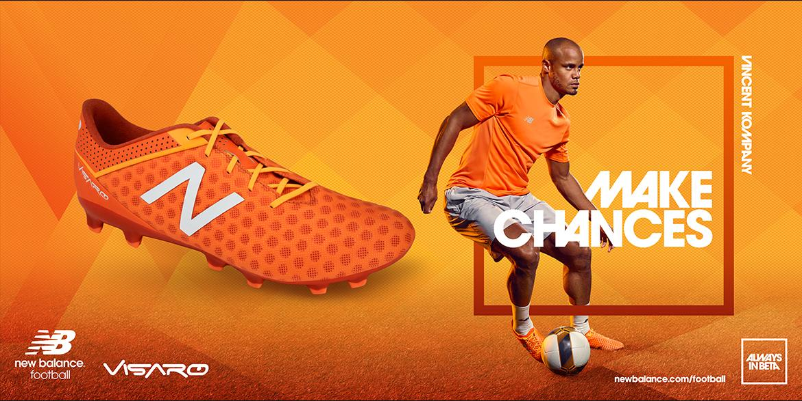

Invention Worksheet—
Rhetorical Analysis
Answer each question, referencing written and visual evidence from the advertisement to support your conclusions about how the ad uses rhetoric to achieve a purpose and send a message. Your work on this invention worksheet will provide you with claims and evidence that you can use to write your Rhetorical Analysis.
This worksheet is due at 10:30 p.m. on Sunday, September 12.

Thesis statement
Advertising plays a crucial role in the presentation of business and is considered one of the most important strategic vehicles in marketing. In most situations, consumers usually tend to ignore advertisements. For this reason, to effectively catch the attention of the potential consumers, companies have continued to struggle to create advertisements that are not only appealing to the consumer’s emotional level but also appealing to their rational levels by enhancing a products reliability and authenticity in the eye of consumers. New Balance Visaro has appended the image of renowned professional soccer player in its advertisement to create much stronger bonds between the brand and the consumers. The brand has used someone who is likable and worthy of respect to give them the competitive advantage over their competitors. Understandably, this advertisement is arguably informational and informs the readers about the existence of this amazing product. The choice of language in this ad is expected to elicit positive emotional response from the consumers. MAKE CHANCES is considered an effective technique applied in the ad to highlight the persuasive reasons to back up the claims for having to choose this brand.
I. Rhetorical Situation Information About Your Advertisement
Ads typically try to sell a product (like Nacho Fries!) or try to deliver a specific message. Determine which is most relevant for your ad, and answer the corresponding questions below.
A. Products
a. Product Being Advertised: this creative ad displays New Balance Visaro boots as the ultimate athletic shoe that delivers an ultimate supportive and comfortable sporting experience.

b. Company that produces the product and is thus the sponsor (author) of the ad? New Balance, a footwear manufacturing company is the sponsoring company of this advertisement.

c. What is the purpose of the product? This ad is particularly aimed at informing and persuading consumers. The inclusion of the special image of Vincent Kompany is particularly meant to create a strong desirable deduction and as well as strong emotions towards the advertised product.

d. Approximately how much does the product cost? On Amazon, the prices for this product range between 54 dollars and 139 dollars inclusive of shipment costs.
e. Who would be most likely to use the product? Soccer athletes are most likely to use this product.
B. Messages
a. What message is the ad trying to send? The ad contains both persuasive and informative messages urging consumers to get a pair of similar boots so they can also make changes like Vincent Kompany, a soccer star in the English football league.
b. Who is sponsoring (and thus the author of) this ad? Believably, the ad has been sponsored by its promoter, the manufacturing company New Balance footwear company.
c. What is the purpose of the message? The main purpose of this message is to create awareness of this brand among potential customers. Additionally, this ad also attempts to educate consumers about the attributes and benefits of the product.
d. Are there costs associated with answering the message? Believably, there are no costs associated with answering the message because the costs had been previously catered for by the company whose product is being advertised under the cost per impression.
e. Who would be most interested in this message? Men particularly those engaging in professional soccer would be most interested in this message.

Publication Source
- Who are the primary readers/viewers of this ad? Consider some of the relevant details of the readers’ social identity—such as class, race, gender, sexuality, age, religion, special interest, etc.
Football shoes such as the one shown in the ad are specially designed to be worn by males participating in soccer. Notably, these shoes have been specifically designed for the pitch. For this reason, I consider professional male soccer players as the primary viewers of this ad. There are social specifications as to who may wear these shoes.

- Where would you expect to see this ad? Is the general readership/viewership the same as the target consumers for your ad? Explain why (or why not) you believe the target consumers are part of the source’s general readership. Consider ways in which the target audience for the ad might be narrower than the target audience for the source as a whole.
Even though this is a targeted advertisement, the viewership is, however, general and everyone can access and read the contents of the ad. It is however important to note that just like many other advertisers, New Balance company may use online advertising that focuses on specific traits and interests and preferences of consumers to display products that they may like. This form of targeted advertising online in my opinion can be used by the advertiser to get the attention of the targeted audience like the professional soccer players.
II. Rhetorically Analyzing Your Advertisement’s Claims and Evidence
- ETHOS (CREDIBILITY): What kind of ethos does your advertisement try to assign to the product or to the company selling the product? Does the ad try to establish a particular image for the product or company—that is, an ethos or character for the product or company? Describe the image the ad projects about the product or company.
Ethos is a persuasive technique that appeals to an audience by highlighting the credibility of a product. In this advertisement, the advertiser has appended Vincent Kompany’s image to assert the credibility of this product. The use of this image in this advertisement is particularly meant to create the impression that the manufacturing company is reliable and can be trusted. Based on this advertisement, it can be noted that New Balance footwear company is thus credible and trustworthy than any other company specializing in the manufacture of professional athletic footwear for men.

WRITTEN EVIDENCE: “MAKE CHANCES” represents one of the written ethos trying to highlight the reliability of this product. Essentially, it is claimed that with these shoes on, players are able to magically create and make chances that would have not been otherwise possible.
VISUAL EVIDENCE: The inclusion of Kompany's image in this advertisement is visual evidence of the use of ethos. Celebrity endorsement is essential in building credibility and exposing new product brands to new markets. Kompany is a soccer celebrity naturally commanding the attention of his fans and that of the club. Featuring his image in this ad is thus particularly meant to grab the attention of these potential customers and consequently enhance the brand visibility.
2. PATHOS (EMOTIONS): What appeals to emotion does your ad employ? (Remember to list specific emotions.) Once you have stated the ad’s (implied or explicit) primary emotional claim, use the space below to list the most important written and visual evidence the ad uses to support that claim. This ad uses visual and written information to create positive emotions associated with intentions to purchase among potential consumers. These include the use of Kompany’s image, presentation of fashionable and cute shoes and the impression created by the words, “MAKE CHANCES.” Notably, these presentations invite positivity and encourage consumers to be associated with the product accordingly.
EMOTIONAL CLAIM(S): positive words about the product such as MAKE CHANCES can arguably trigger feelings of curiosity and internal excitement consequently driving the consumer to buy these shoes and try them out. Similarly, the appended slogan also instils a fiery sense of motivation and the avoidance of hesitation and regrets consequently helping to build inspired emotions in the target audience.
WRITTEN EVIDENCE: Besides creating an emotional response, the written evidence, MAKE CHANCES can also positively assist in the creation of a consumer-driven culture to buy.
VISUAL EVIDENCE: the ad depicts cute and fashionable sportswear for men that are observably attractive and may enhance the feelings of curiosity consequently inviting the potential customers to give them a try.

- PATHOS (VALUES) What appeals to specific values or identities does your ad employ? Once you have stated the ad’s (implied or explicit) primary value or identity claim, use the space below to list the most important written and visual evidence the ad uses to support that claim.
Notably, the specific values attached to the ad include the creation of the impression that the use of the product would surely place users on the winning side.
VALUE/IDENTITY CLAIM: The information contained in this ad creates the impression that using the New Balance manufactured shoes for sporting activities would surely put you on the winning side by helping you MAKE CHANCES. Because of this, for the fear of being left out, the ad is attempting to attract as many people as possible.
WRITTEN EVIDENCE: The written evidence MAKE CHANCES may consequently put pressure on men playing soccer to acquire this product because it is significantly associated with success.
VISUAL EVIDENCE: Just like the written evidence, the visual representation of Vincent Kompany in this ad puts the company’s brand on the right side of popular opinion. Many potential consumers may consequently purchase the product in the belief that it would eventually transform them into soccer giants like Vincent Kompany.
- LOGOS: What appeals to reason does your ad employ? (In other words, what factual claims does the ad make about the quality and the characteristics of the product?) Once you have stated the ad’s primary appeal to reason, use the space below to list the most important written and visual evidence the ad uses to support that claim.
Logos are particularly meant to appeal to the audience through the use of logic and reason to convey a point of view and consequently win over the audience. The ad displays the features of the product in a close view besides proving that it has a better grip on the pitch.
APPEAL TO REASON: The rational appeal to reason attempts to persuade the audience to purchase the product. The representation of a soccer icon in this ad makes a rational appeal that can’t be disputed.
WRITTEN EVIDENCE: The written evidence MAKE CHANCES has been logically crafted to compliment the other persuasive aspects of the ad.
This is considered a minimalistic and motivating slogan; this written evidence gives the company a credible authority as a sports icon.
VISUAL EVIDENCE: Using celebrity representation perpetuates logic that the company’s products are arguably the best in the market right now and have been universally accepted by top brands in the footballing world.
2
III. Your Advertisement’s Use of Rhetoric to Send a Message
- What rhetorical appeals and which elements of visual rhetoric are used most in the ad to achieve its purpose?
Pathos, ethos, and logos have been used in the ad to achieve its purpose. Additionally, elements of visual rhetoric such as images and texts have also been used to effectively complement the rhetoric elements.
- Based on its target audience, why does the ad use specific rhetorical appeals and visual rhetoric?
Because this ad contains a product that is specifically targeted, the use of specific rhetorical appeals and visual rhetoric has been specifically incorporated to logically convince the potential buyers that the product advertised is actually the best. The product stems from a credible authority as a sport’s icon because of these rhetoric elements.
- What message does the ad seem to be sending? The message is different from the purpose— for example, an ad may try to sell you a car while also sending the message that the company that makes the car is environmentally responsible.
The message the ad is trying to send is that these products are recommended to achieve improved athletic performance.
- Why is this message appropriate for the target audience?
The message is appropriate for the target audience because instils a sense of credibility in the brand consequently enhancing the reputation of the company.

